**Problem Statement**

* In today’s world security is one of biggest aspect people look forward to whether it’s their family members protection or their precious valuables protection.
* After having so many elementary solutions to the security problems,(like Intrusion Alarm, Hold-n-panic Alarm, CCTV etc.) there are lot of robbery reports been filed daily.
* To improve the situations we have come up with new idea to protect your valuables.

**Solution**

* “OBSCURE LOCK”
* This system will provide with virtual lock mechanism that can be used in any locker/safe/block of the showroom which will be operated using a Mobile Application with the concepts of augmented reality.

**Project Description**

* Today, security is a major area of concern for people with a lot of precious elements, gems, jewels etc. Whether your company is a small local shop or a major international business, you must remain cognizant of the potential security issues facing your organization. To overcome these issues many security methods are designed and developed.
* For a better approach to the issue, the system “OBSCURE LOCK ” is designed and developed for the betterment of the jewellery showroom. This system will provide with virtual lock mechanism that can be used in any locker/safe/block of the showroom which will be operated using a Mobile Application with the concepts of augmented reality. The mobile application will use camera and will augment pattern dots or numeral while facing the objects. You have to draw/write the correct pattern/numeral to unlock the Locker/safe/block which is under the surveillance of the “ OBSCURE LOCK App ”.
* The block will open instinctively once the password/pattern is correctly entered. This functionality is performed using an IOT sensor and analyze weight inside the block/safe.
* Another sort of functionality that is provided by the system is a chain of blocks between the user. The authentication of each user is accomplished using blockchain notion.

**SRS**

|  |  |
| --- | --- |
| Topic | Page No. |
| ***INTRODUCTION*** |  |
| 1.1 Purpose |  |
| 1.2 Document Conventions |  |
| 1.3 Intended Audience & Reading Suggestions |  |
| 1.4 Product Scope |  |
| 1.5 References |  |
| ***OVERALL*** ***DESCRIPTION*** |  |
| 2.1 Product Perspective |  |
| 2.2 Product Functions |  |
| 2.3 User Classes & Characteristics |  |
| 2.4 Operating Environment |  |
| 2.5 Design & Implementation Constraints |  |
| 2.6 User Documentation |  |
| 2.7 Assumptions & Dependencies |  |
| ***EXTERNAL*** ***INTERFACE*** ***REQUIREMENTS*** |  |
| 3.1 User Interfaces |  |
| 3.2 Hardware Interfaces |  |
| 3.3 Software Interfaces |  |
| 3.4 Communication Interfaces |  |
| ***SYSTEM*** ***FEATURES*** |  |
| 4.1 System Feature 1 |  |
| 4.2 System Feature 2 |  |
| 4.3 System Feature 3 |  |
| 4.4 System Feature 4 |  |
| 4.5 System Feature 5 |  |
| 4.6 Provide Online Help and Tutorials |  |
| ***OTHER*** ***NON-FUNCTIONAL*** ***REQUIREMENTS*** |  |
| 5.1 Customer Requirements |  |
| 5.2 Transaction Requirements |  |
| 5.3 Accounting Requirements |  |
| 5.4 Security Requirements |  |
| 5.5 Software Quality Attributes |  |

**INTRODUCTION**

* 1. PURPOSE

This Software Requirement Specification(SRS) document is intended to provide a complete overview of our project “OBSCURE LOCK’s” mechanism, user interface and story therein. This SRS constituent of all the specifications upon which obscure lock is rooted with reference to their implementation.

* 1. DOCUMENT CONVENTION

This convention followed for writing this document is IEEE recommended practice for Software Requirement Specification. We choose Calibri(body) as font for the entire report and different sizes of the fonts for main heading, sub heading, and for paragraph .

|  |  |  |  |
| --- | --- | --- | --- |
| Heading Type | Font | Font Size | Font Weight |
| Main Heading | Calibri(Body) | 18 | Bold |
| Sub Heading | Calibri(Body) | 14 | Normal/Uppercase |
| Paragraph | Calibri(Body) | 14 | Normal |

* 1. INTENDED AUDIENCE AND READING SUGGESTION

The SRS archive is perusing the distinctive sort on lookers that the report is designed for, the developers, jewellery stores executives, server handlers of the store and document authors.

* 1. PRODUCT SCOPE

The “Obscure Lock ” is an augmented reality-based application which helps emporium possessor to embed the best of security to their stores. This application will be available on our web portal which will be given to the executives of the store to open and close the safe.

The executives will be given a user manual and demonstration sessions will be provided to enhance their knowledge regarding our application.

1.5 REFERENCES

IEEE format is pursued.

**OVERALL DISCRIPTION**

2.1 PRODUCT PERSPECTIVE

The system “OBSCURE LOCK ” is designed and developed for the betterment of the jewellery showroom. This system will provide with virtual lock mechanism that can be used in any locker/safe/block of the showroom which will be operated using a Mobile Application with the concepts of augmented reality. The mobile application will use camera and will augment pattern dots or numeral while facing the objects. You have to draw/write the correct pattern/numeral to unlock the Locker/safe/block which is under the surveillance of the “ OBSCURE LOCK App ”. The block will open instinctively once the password/pattern is correctly entered. This functionality is performed using an IOT sensor and analyse weight inside the block/safe. Another sort of functionality that is provided by the system is a chain of blocks between the user. The authentication of each user is accomplished using blockchain notion.

The top level diagram depicts the complete user features that are on their ways for users

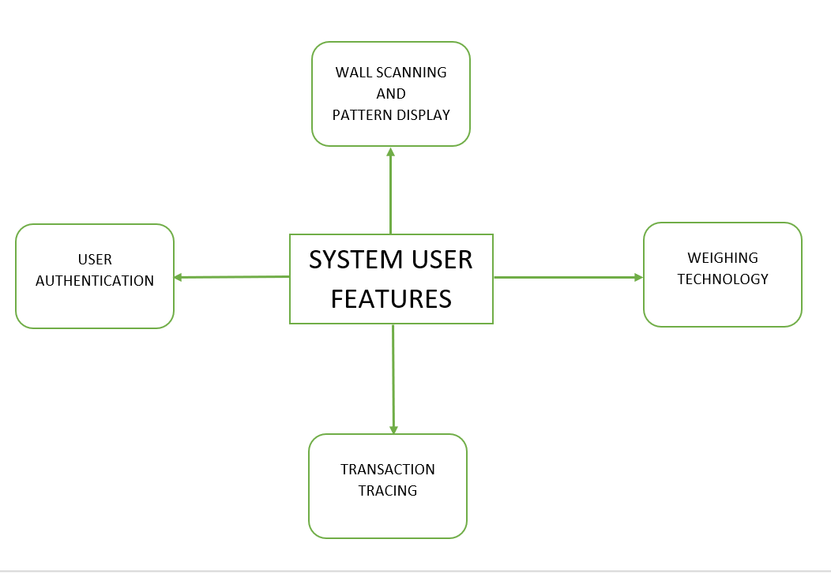

* 1. PRODUCT FUNCTION

The fundamental attribute of our system which builds the system:

1. Obscure: The system is invisible to the surroundings. There are some particular users been defined by the owners of the emporium to whom this is visible through there gadgets .
2. User Authentication: Every individual who is a part of the system is provided with a user substantiation password which is noticeable only when user keep their mobile phones facing the walls.
3. Wall Scanning: When a particular individual whose is a responsible handler of the system keeps there mobile facing the walls a scanning takes place to examine the wall is under the surveillance of our system.
4. Weighing Technology: Once a user tries to keep something or take out anything from the safe weight of the safe is calculated and recorded each time.

* 1. USER CLASSES AND CHARACTERSTICS

1. Data Analyst: These people are the one who operates the database of the system within the emporium.
2. Showroom Executives: They handle the safe directly by their mobile phones which helps them open and close the safe.
   1. OPERATING ENVIRONMENT

|  |  |  |
| --- | --- | --- |
| Particulars | Client System | Server System |
| Operating System | Android  IOS | Platform independent(Web based) |

* 1. DESIGN AND INPLEMENTATION CONSTRAINTS

There is no such constraints for the design and implementation of the system for now.

* 1. USER DOCUMENTATION

The primary goal of “Obscure Lock” System is to facilitate the process of managing security of the precious gems . Consequently, the application will be designed to be as simple as possible. Nonetheless, users may still require some supplementary information about each component of the system. The application will contain two features: Tutorials and Help Menu.

2.7 ASSUMPTION AND DEPENDENCIES

Basic functionalities have the highest priority here and they will be implemented first. Optional features, however, are not critical to the function of the application. They are usability improvements and convenience enhancements that may be added after the application has been developed. Thus, the implementation of these features is entirely dependent upon the time spent designing and implementing the core features. The final decision on whether or not to implement these features will be made during the later stages of the design phase.

**EXTERNAL INTERFACE REQUIREMENT**

3.1 USER INTERFACE

* Wall Scanning

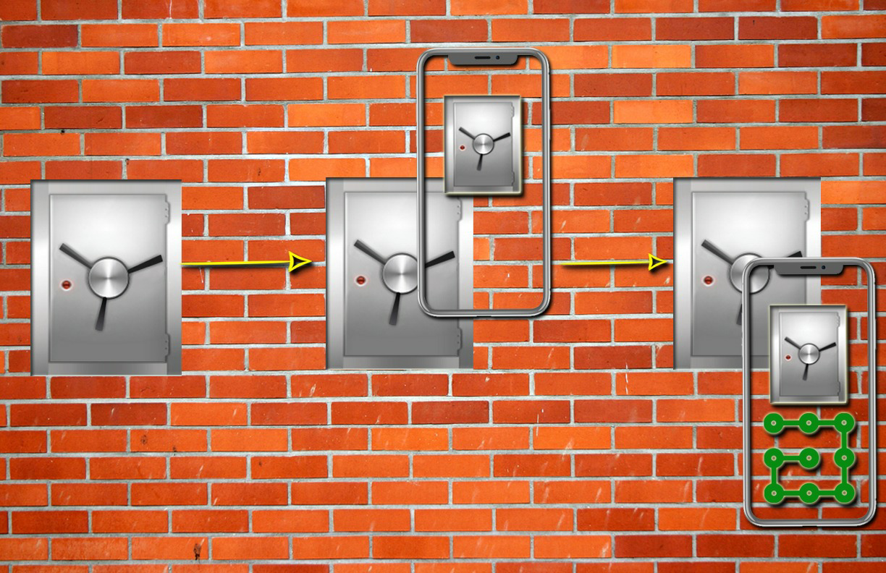

* Opening the doors

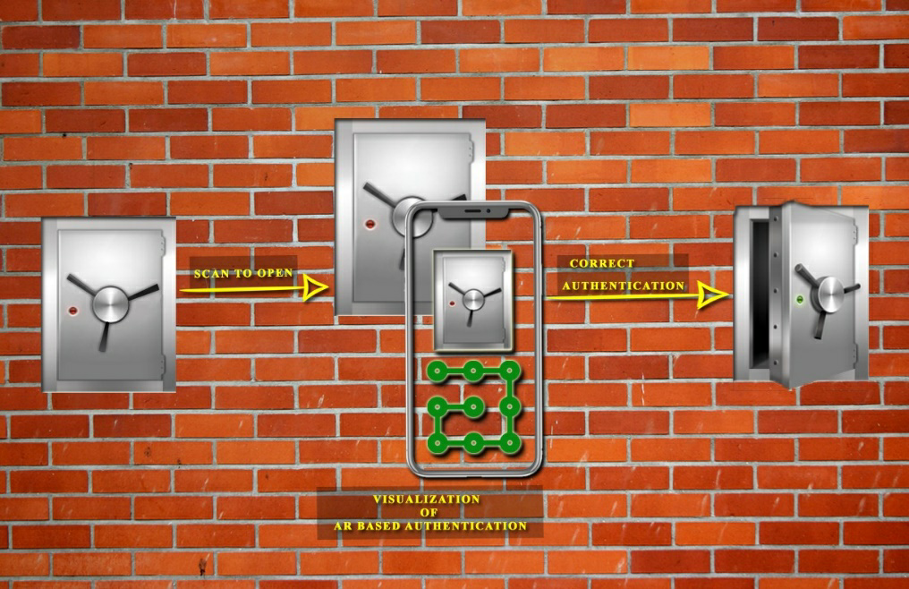

* Weighing the amount of gold inside
* Closing the doors

3.2 HARDWARE INTERFACE

* Phone Walls of Safe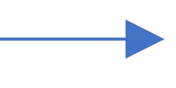
* Phone Lock
* Lock Servo Motor
* Servo Motor Lock
* Sensors Weighing Machine

3.3 SOFTWARE INTERFACE

Back End software’s

|  |  |
| --- | --- |
| **Software Parts** | **Description** |
| Operating System | Windows/Linux |
| Database | Firebase |

Front End software’s

|  |  |
| --- | --- |
| **Languages** | **Description** |
| Vuforia | For Augmented Reality |
| Ethereum IDE | Blockchain |
| Flutter | IOS and Android Apps |
| Deep Learning | Wall Scanning |

**SYSTEM FEATURES**

4.1 SYSTEM FEATURE 1 : OBSURE

The Obscure technology is introduced as it has zero visibility to the surroundings. Also using this feature makes it more secure as compared to the current security mechanisms.

4.2 SYSTEM FEATURE 2 : WEIGHING FACILITIES

This feature helps the user to keep track of the weight in the safe every time the user keeps something or takes out something. It calculates the weight and keeps record of the same.

4.3 SYSTEM FEATURE 3 : USER AUTHENTICATION

Every individual who is a part of the system is provided with a user substantiation password which authenticates only when user keep their mobile phones facing the walls.

4.4 SYSTEM FEATURE 4 : TRACING TRANSACTIONS

Each time a executive tries to open the safe the transaction of him opening and closing the doors of the safe is recorded and the weight of the safe is recorded each time.

4.5 PROVIDE ONLINE HELP AND TUTORIALS

Once the product is deliver we will look after its post delivery services. We will provide some tutorials to the company who purchases the product as well as free online help through our experts and technicians over the call . Also we will send our assistance at the doorstep as well.

**OTHER NON-FUNCTIONAL REQUIREMENTS**

Non-functional requirements are requirements that are not directly concerned with the specific functions delivered by the system. They may lead to emergent system properties such as reliability, response time and storage occupancy. They may specify system performance, security, availability and other emergent properties.

5.1 CUSTOMER REQUIREMENTS

The system shall allow users to access the system from phone only. The users will be given instruction regarding the usage of the applications.

5.2 SECURITY REQUIREMENTS

Every users will be provide or shall make there passwords according to their convenience. Nobody can open the doors without having the passwords. Every transaction performed will be noted in the database. The weight included or excluded and the time of include and exclude from the safe will be stored in the databases.

* 1. SOFTWARE QUALITY ATTRIBUTES
* Reliability : The system should be available at 99.9% of the time. A backup should be built for abnormal situations and maintenance access.
* Maintainability: The system should demonstrate that its design provides maintainability taking from users interface from all the other functions.
* Portability: The system should demonstrate portability on the following platforms Android, IOS, Windows.
* Usability: The system should require minimum guidance. Easy to use.

**UNIFIED MODELLING LANGUAGE**

**USE-CASE**

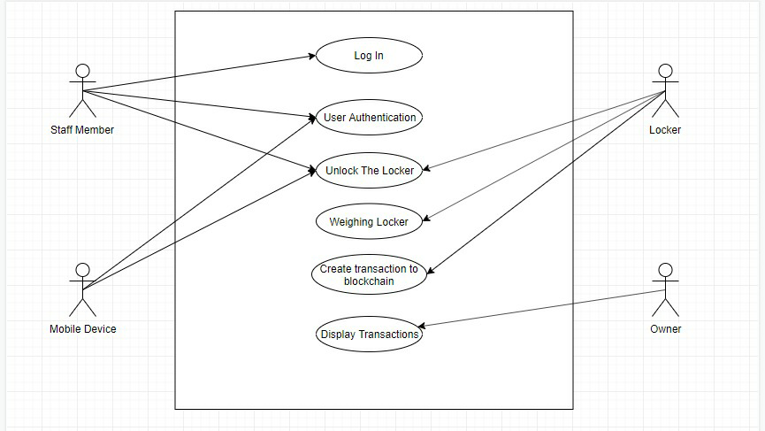

**CLASS DIAGRAM**

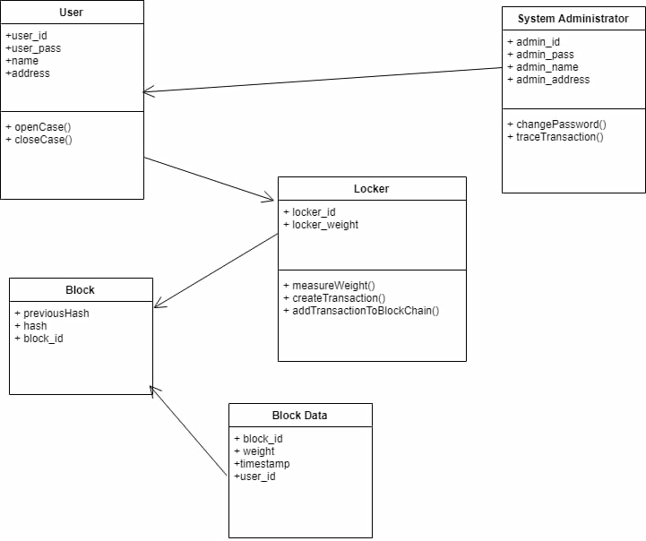

**SEQUENCE DIAGRAM**

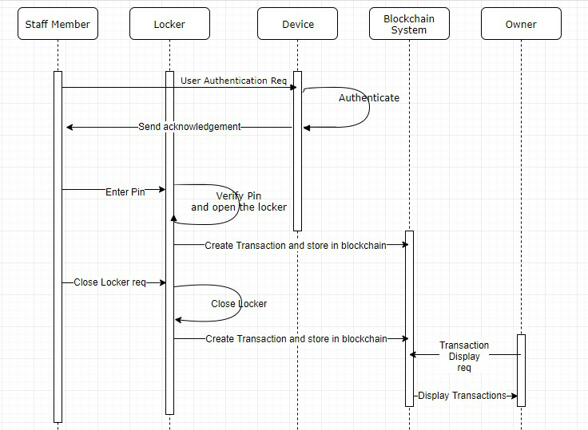

**ACTIVITY DIAGRAM**

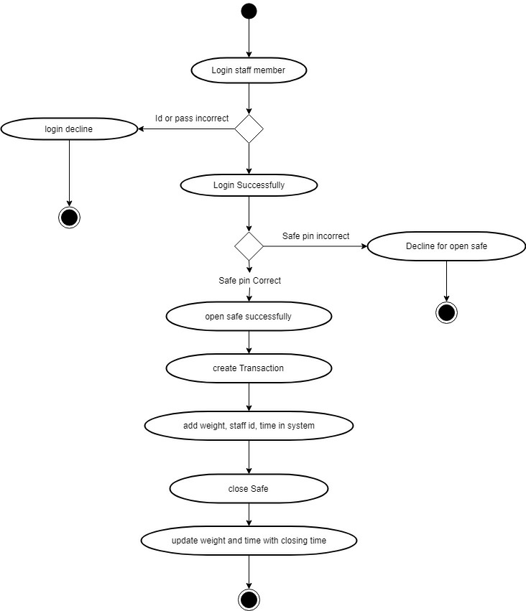

**GANTT CHART**

**DATABASE DESIGN**